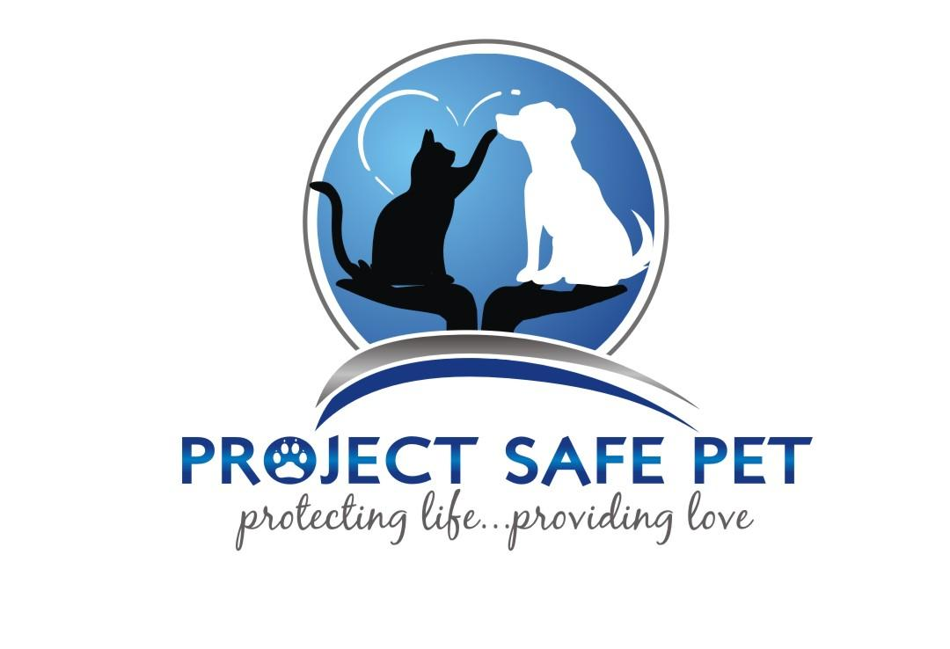
RESCUE FOSTER PROGRAM

Thank you for your interest in joining the PSP Rescue Program as a foster parent.
We hope this will be a wonderful and rewarding experience for you.

Project Safe Pet, Inc. assists several out of State Rescue Organizations with animals they want to bring into their group. These dogs and cats need to stay in volunteer foster homes until they are ready for transport. Often these animals are in need of socialization and training. Our foster parents volunteer their time and money to give them the care and attention they deserve. The ongoing issue of at-risk animals due to overpopulation and abandonment provides for a constant need to find suitable, loving foster homes.

Fostering is a big responsibility and needs to be considered thoughtfully. Taking the animals to vet appointments and the transport meeting spot at the end of the foster period is part of the commitment. Additionally, rescue animal may have a contagious disease and need to be isolated from other pets until they recover. Social issues like dominance and territorial behavior must also be handled slowly and carefully; allowing each animal the opportunity to find their place in the group.

It is very easy to develop a close bond with foster animals. And, although giving them up to their adoptive family is difficult, another suffering animal is then given a chance at the same loving experience. Keeping this in mind helps us remember how important this process is to help the most innocent creatures.

If you are interested in fostering, please take some time to consider the types and sizes that would fit best in your household as animals are carefully placed in foster homes most ideally suited to their temperaments and needs. Then, complete PSP’s Foster Questionnaire. A volunteer will be in contact with you shortly after receiving your application

Contact Info:

Name: _________________________________________________________
Email Address (name@domain.com) : ________________________________
Address: ___________________________________________________________________
City, State, Zip: __________________________________________________
Home Phone (incl. area code): _______________ Work Phone (incl. area code): _______________
Employer: ______________________________________________________

Home Information:

Do you live in (check one): __House __Apartment/Condo __Duplex
How long have you lived there? __________________
Do you own or rent your home? (check one) __Own __Rent
If you rent, have you paid a pet deposit (check one): __Yes __No
Landlord's Name & Phone Number: ______________________________________________

# Adults in the home: ___ # Children in the home: ___
Children's ages: ________________________________

Do you or anyone in your household or immediate family have allergies or asthma?
__Yes __No __Don't Know

Do you currently have pets? __Yes __No
If yes, types & ages: _____________________________
List other pets you have had in the past 5 years:
___________________________________________________________________________

Are your pets:
 Spayed/neutered? __Yes __No
 Treated regularly for fleas? __Yes __No
 Declawed? __Yes __No
 Current on all vaccines? __Yes __No
 Tested for Leukemia? __Yes __No
 (check one) __Indoor Only __Outdoor Only __Indoor & Outdoor

Your Veterinarian's Name: _________________________________________
Vet. Hospital: ____________________________________________________

Foster Information:

Do all your household members agree to your fostering animals? __Yes __No
Do you have transportation? __Yes __No

What other animal organizations have you worked with?
___________________________________________________________________________

Why do you want to foster animals?
___________________________________________________________________________
___________________________________________________________________________
___________________________________________________________________________
___________________________________________________________________________
___________________________________________________________________________

What experience do you have fostering animals?
___________________________________________________________________________
___________________________________________________________________________
___________________________________________________________________________
___________________________________________________________________________

What type & ages of animals would you like to foster?
___________________________________________________________________________
___________________________________________________________________________
___________________________________________________________________________

What special talents, skills & experiences can you contribute to Project Safe Pet?
___________________________________________________________________________
___________________________________________________________________________
___________________________________________________________________________
___________________________________________________________________________

